

Feedonomics Integration Guide

Version: 20.1.0

Contents
2.1. Functional Overview 1
2.2. Use Cases 1
2.2.1. FeedonomicsProductExport Feed 1
2.2.2. FeedonomicsProductInventoryExport Feed 1
2.3. Limitations & Constraints 1
2.4. Compatibility 1
2.5. Privacy 1
3.1. Setup 1
3.1.1. Install Site Meta-Data 1
3.1.2. Cartridge Path 1
3.1.3. Service Definitions 1
3.1.4. Jobs Configuration 1
3.1.5. IMPEX Directory 1
3.2. Configuration 1
3.2.1 Configure Jobs 1
3.2.1.1 FeedonomicsProductExport 1
3.2.1.2 FeedonomicsInventoryExport 1
3.3 External Interfaces 1
3.3. Availability 1
3.4. Support 1
4.1. Roles, Responsibilities 1
4.2. Business Manager 1

Summary
As a full-featured feed platform, Feedonomics helps you clean your product data and intelligently optimize it for hundreds of different marketing channels. Our dedicated full-service FeedFillment™ team is always there to help with feed set-up, optimization, and 24/7 support to help maximize product performance.
The current version includes support for integration of custom JOB feeds viz. Product Export and Inventory Export Feeds. This document describes how to integrate the cartridge int_feedonomics with your business manager, and assumes you have knowledge about the SFCC Business Manager.
Please contact Feedonomics in the first instance to obtain the (S) FTP credentials to export those feeds to Feedonomics.
This cartridge includes support Controllers, SFRA and Pipelines.

Component Overview

Functional Overview
The cartridge includes the following features:
• Product Export JOB pushes product data assigned to the relevant site to Feedonomics FTP.
• Product Export JOB provides the functionality to push the data in multilocale which can be easily configured through localeID job parameter in custom job component.
- Product Inventory Export JOB pushes the inventory and pricing information of the product assigned to the relevant site to Feedonomics.
- Feed Files are pushed to Feedonomics via (S) FTP.
- Both the JOBs i.e. Product Export JOB and Inventory Export JOB are designed in chunk oriented manner to avoid timeouts owing to large number of products.

Export specifics

FeedonomicsProductExport Feed
A site-level Product export job (‘FeedonomicsProductExport) has been provided as part of this cartridge. This job will export all products assigned to the relevant site to Feedonomics.

FeedonomicsProductInventoryExport Feed
A site-level Inventory export job (‘FeedonomicsProductInventoryExport’) has been provided as part of this cartridge. This job will export inventory allocation and pricing information of all the products assigned to the relevant site to Feedonomics.

Limitations & Constraints
There are not any limitations and constraints for this cartridge .There is not any risk of optimistic locking failure because there is not any transaction associated with any JOB run.

Compatibility
This cartridge is compatible with all the three frameworks of SFCC i.e. pipelines, controllers and latest SFRA. Cartridge has been tested against code compatibility version 19.10.

Privacy
All feeds belong to Feedonomics.

Implementation Guide

Setup

Setting Workspace
This repository contains int_feedonomics cartridge inside the top level folder link_feedonomics under the cartridges folder. Add the int_feedonomics cartridge to the Business manager site cartridge path after uploading.
- Clone this repository. (The name of the top-level folder is link_feedonomics).
- If you are using Eclipse import int_feedonomics project by navigating to the root folder i.e. link_feedonomics and upload using UX studio.
- If you are not using Eclipse then navigate to the link_feedonomics folder where package.json is present.
- In the link_feedonomics folder, run npm install to all the package dependency required.
- Update the file dw.json under the link_feedonomics folder with contents:
{
"hostname":"your-sandbox-hostname.demandware.net",
"username": "yourlogin",
"password": "yourpwd",
"code-version": "version_to_upload_to",
}
- In the link_feedonomics folder, enter the following command: npm run uploadCartridge , this will upload the cartridge to the server.
- Use npm run lint to check any linting error.

Install Site Meta-Data
The site Meta data consists of JOB definition, services and site preference. These must be installed to support the cartridge code. To do this, perform the following:
- ZIP up the metadata directory
- Upload the ZIP file via Administration > Site Development > Site Import and Export.
- Select the file and click Import.

Cartridge Path
The int_feedonomics cartridge must be added to the business manager cartridge path only as it doesn’t have any storefront related functionality. To do this go to Administration > Sites > Manage Sites
Click on Business Manager Sites
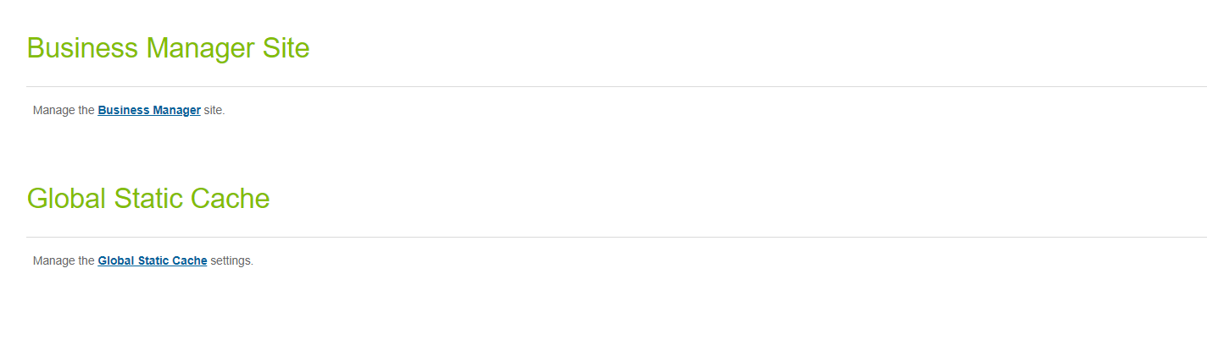
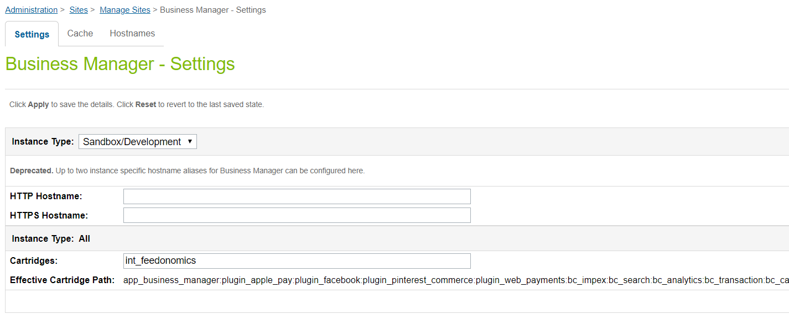

Service Definitions
The new Services framework has been used to enable the feed transfer to Feedonomics using FTP service client.
Service definitions are installed as part of the site import, but will require the following configuration:
Go to Business Manager, navigate from Administration > Operations > Services
Click on credentials Tab and click feedonomics.ftp.creds link.
- Credentials URL : FTP Host
- User / Password: User Name and Password for FTP connection.
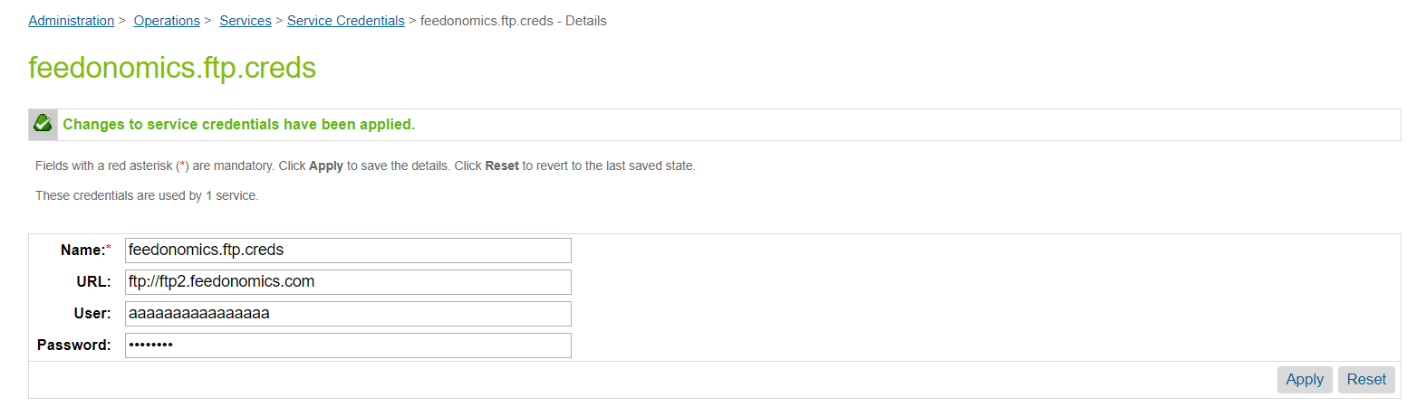

Jobs Configuration
All scheduled jobs provided as part of the cartridge must be configured as required. As implementer requirements will vary, this configuration has been omitted from the cartridge meta-data. Specifically, the following must be configured for each Job:
- Enabled/Disabled
  - All jobs are disabled by default
- Schedule
  - Job schedule and interval to be defined
- Notification Settings
  - Email notification to be provided in the event of job failure
  - This should be set to a current and active email address which is monitored so that issues can be identified and resolved.
Product Export Feed is currently configured for default locale only. If the requirement is for multilocale then create a new job component inside the job and pass the locale id. Please refer to configure job section for detailed steps.
*** In case job is disabled for BM account then navigate to
Administration > Organization > Roles > Administrator - Business Manager Modules to enable Jobs and Job history
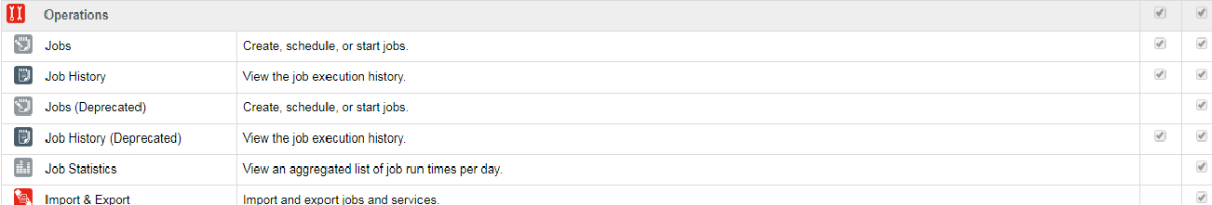

IMPEX Directory
IMPEX directory can be monitored by the respective JOBs itself but after the initial import of the metadata default values of the site folders will be there and they can be overridden in JOB components.

FeedonomicsProductExport Feed:
Target Folder: src/feedonomics/catalog
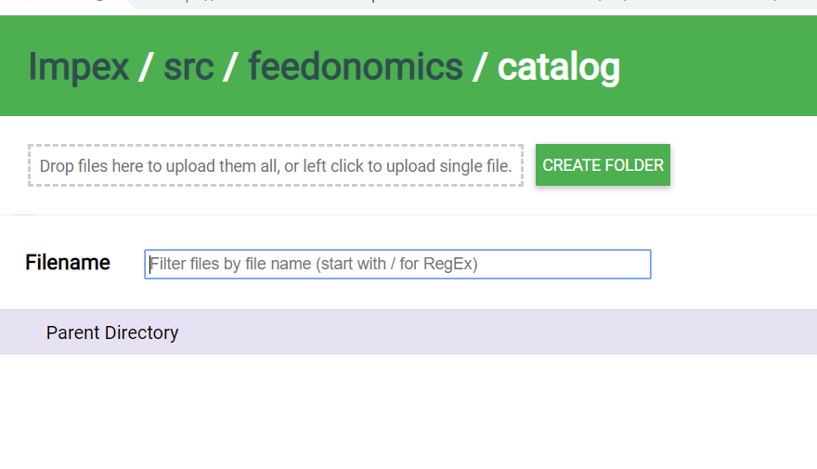
FeedonomicsProductInventoryExport Feed:
Target Folder: src/feedonomics/inventory
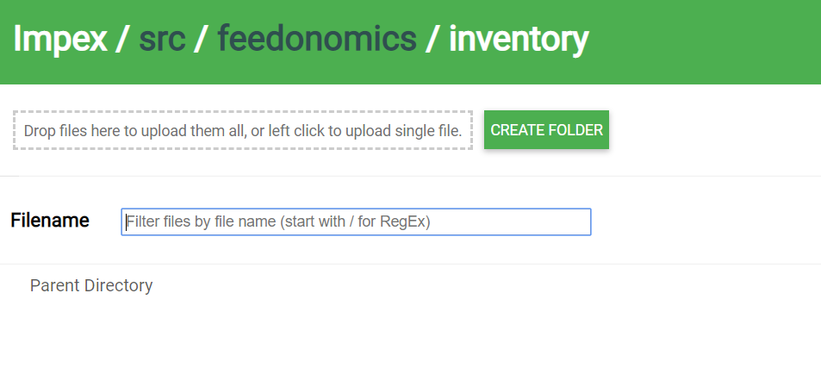
FTP Upload:
Archive Folder: src/archive/feedonomics
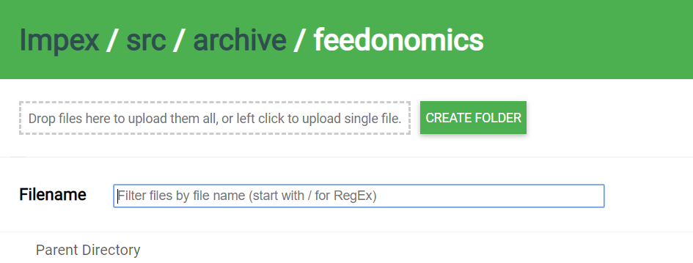

Configuration

Configure Jobs

FeedonomicsProductExport
Feedonomics Product Export job runs in site context which exports all the products assigned to the site. This job supports the multilocale functionality which creates the specified locale file at the IMPEX and later upload the same to the FTP location specified in the feedonomics.ftp service.
- A custom feedonomics product export job component has been created as part of this job which is managed by code’s steptype.json.
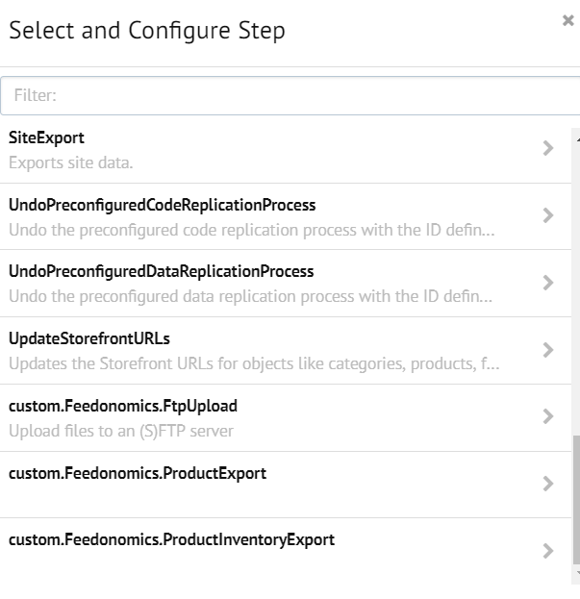
custom.Feedonomics.ProductExport: This custom job component creates a new CSV format file at IMPEX and writes all the product data to that.
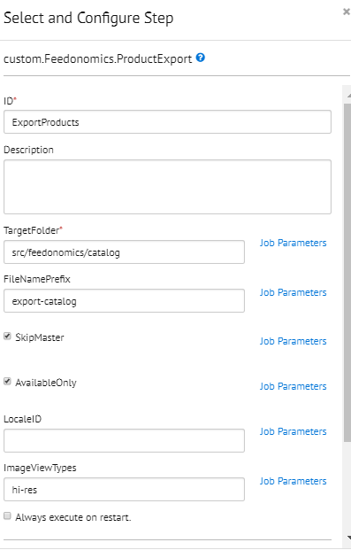
This component has six job parameters:
- TargetFolder: Location respect to IMPEX directory where product export feed file will be written.
- FileNamePrefix: File Name prefix of the product export feed file. If this file has been set up for dummy id site and locale is en_US then file name will be export_product_dummy_en_US.csv
- SkipMaster: This parameter will skip the master products and default value is set as true. Uncheck this parameter to include master products also in the feed.
- LocaleID: This parameter sets the request locale to the specified value in this field and if keep empty it will be considered as default locale. Please specify the site locale id to create a locale specific file otherwise keep it empty for default locale.
- AvailableOnly: This parameter sets the request for instock products only. Default value set as true, unchecking this parameter includes all products.
- ImageViewTypes: This parameter is used to retrieve the product images for custom viewtypes defined separated by comma. E.g. hi-res,medium
- OnlineOnly: This parameter sets the request for online products only. Default value set as false, checking this parameter will include online products only.
***Select the relevant sites for this job component to export feed files.
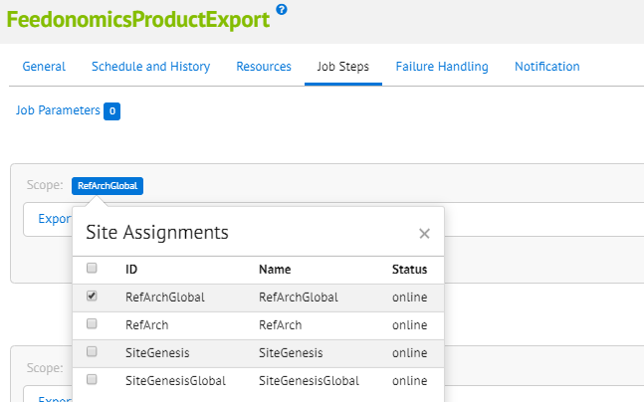
The default import of the metadata will create this JOB only for default locale only. As per the requirement edit the localeID parameter value to set the required locale.
In case of multilocale please follow the below steps:
- Click on “+” button to add a new sequential flow.
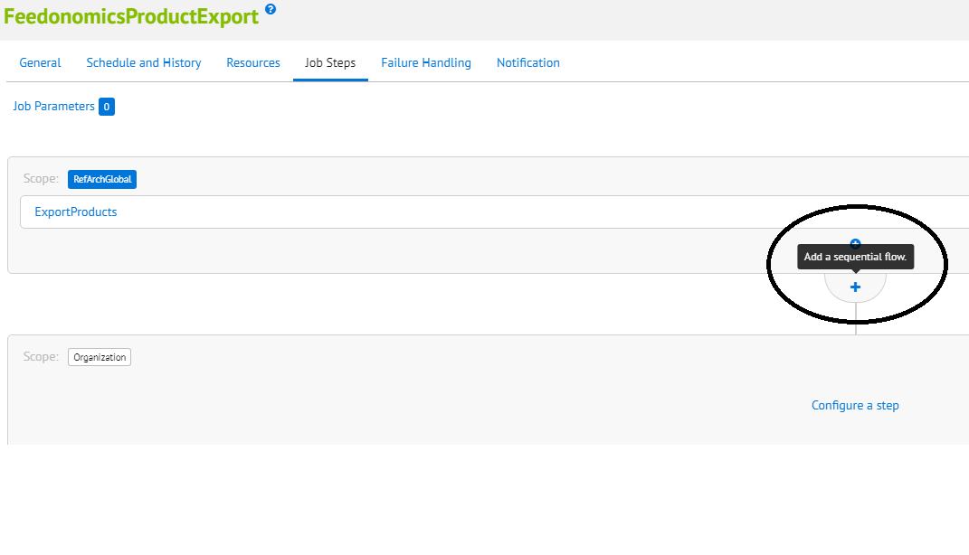
- Click on “Configure a step”.
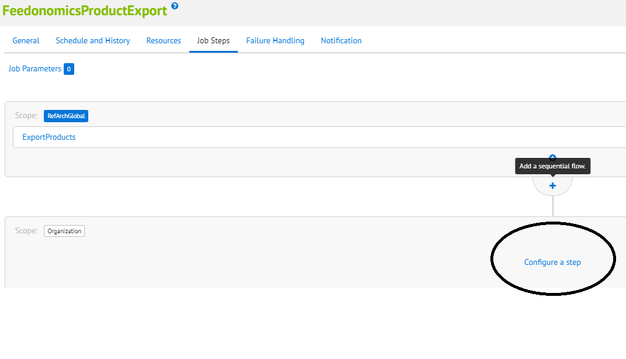
- Under the settings select “custom.Feedonomics.ProductExport” as the job component.
- Enter ID i.e. a name for job step e.g. “ExportProduct_fr_FR”
- Enter the LocaleID of the locale for which feed needs to be exported. Refer to Administration > Global Preferences > Locales for the list of localedIDs
- Once added, set the scope by clicking the “Organization” box next to Scope and select the Site for which the feed needs to be exported.
Follow the steps above to set up separate job step for each Site – Locale combination. It is advisable to select only one site_id per locale job step.

- Create as many as JOB components as a sequential flow, use the exact default component definition and update the localeID value as per requirement. In below example JOB will export two product feeds one is default locale and other one in FR locale.
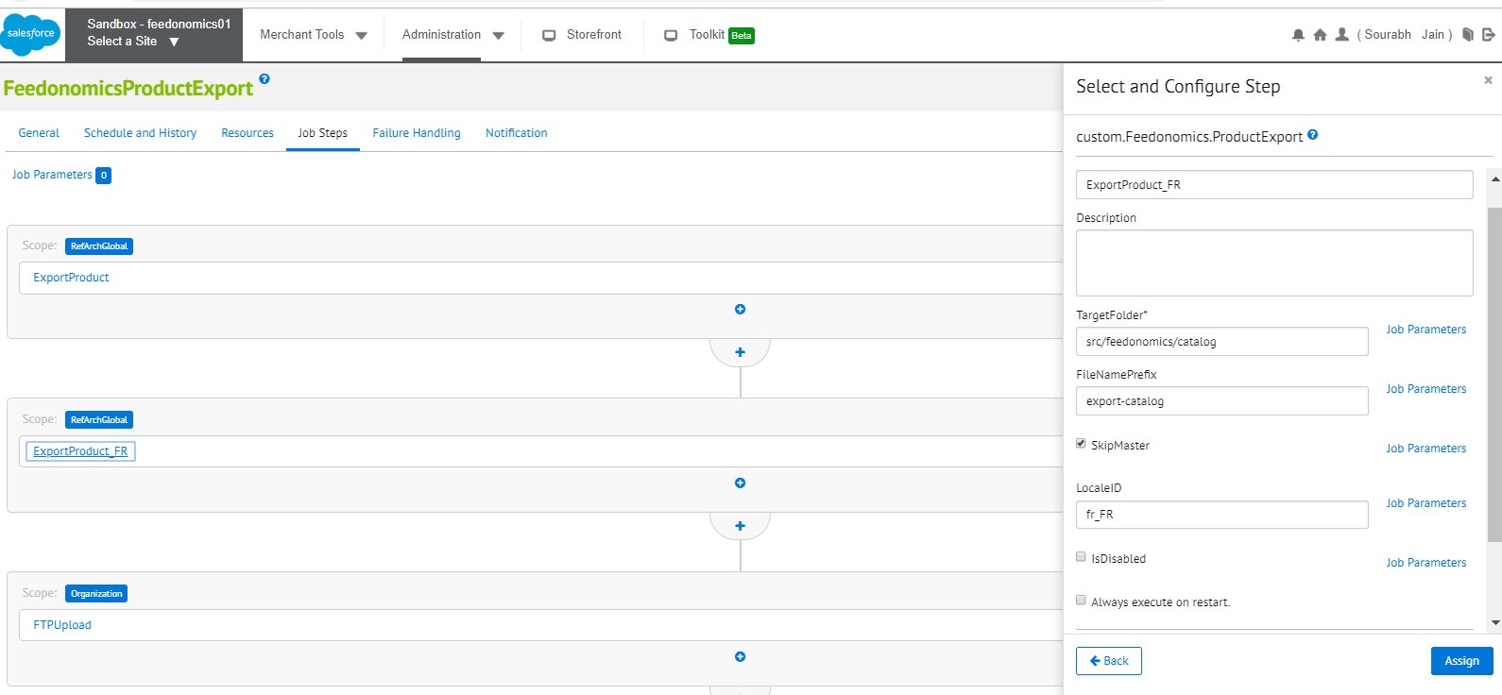
In case of multi storefront multi locale export either create a new job definition or create a separate job component if particular locale id is not available for other site.
In case locale ID is unavailable this JOB will throw an error.

FeedonomicsInventoryExport
Feedonomics Inventory Export job runs in site context which exports inventory data of all the products assigned to the site. This job writes the inventory and pricing data to the specified CSV format file at the IMPEX and later upload the same to the FTP location specified in the feedonomics.ftp service. This job has two job components:
- custom.Feedonomics.ProductInventoryExport: A custom feedonomics product inventory export job component has been created as part of this job which is managed by code’s steptype.json.
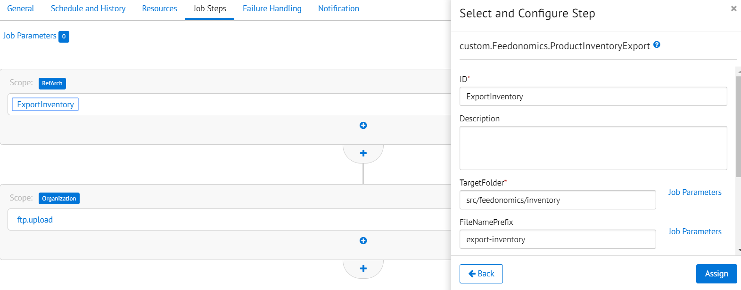
This component has four job parameters:
- TargetFolder: Location respect to IMPEX directory where product inventory export feed file will be written.
- FileNamePrefix: File Name prefix of the product export feed file. If this file has been set up for dummy id site and default locale is en_US then file name will be export_inventory_dummy_en_US.csv
- SkipMaster: This parameter will skip the master products and default value is set as true. Uncheck this parameter to include master products also in the feed.
- AvailableOnly: This parameter sets the request for instock products only. Default value set as true, uncheck this parameter to includes all products.
- OnlineOnly: This parameter sets the request for online products only. Default value set as false, checking this parameter will include online products only.
***Select the relevant site for this JOB step same as product export JOB.
To export inventory for more than one site, create another sequential flow and set “custom.Feedonomics.ProductInventoryExport” as the component.
FTP Upload: For both the JOBs FTP upload will be the last JOB step which can be easily configured via custom.Feedonomics.FtpUpload job component.
- custom.Feedonomics.FtpUpload: This job step uploads the feed files present in source folder to the target folder located at (S) FTP location described as JOB parameter.
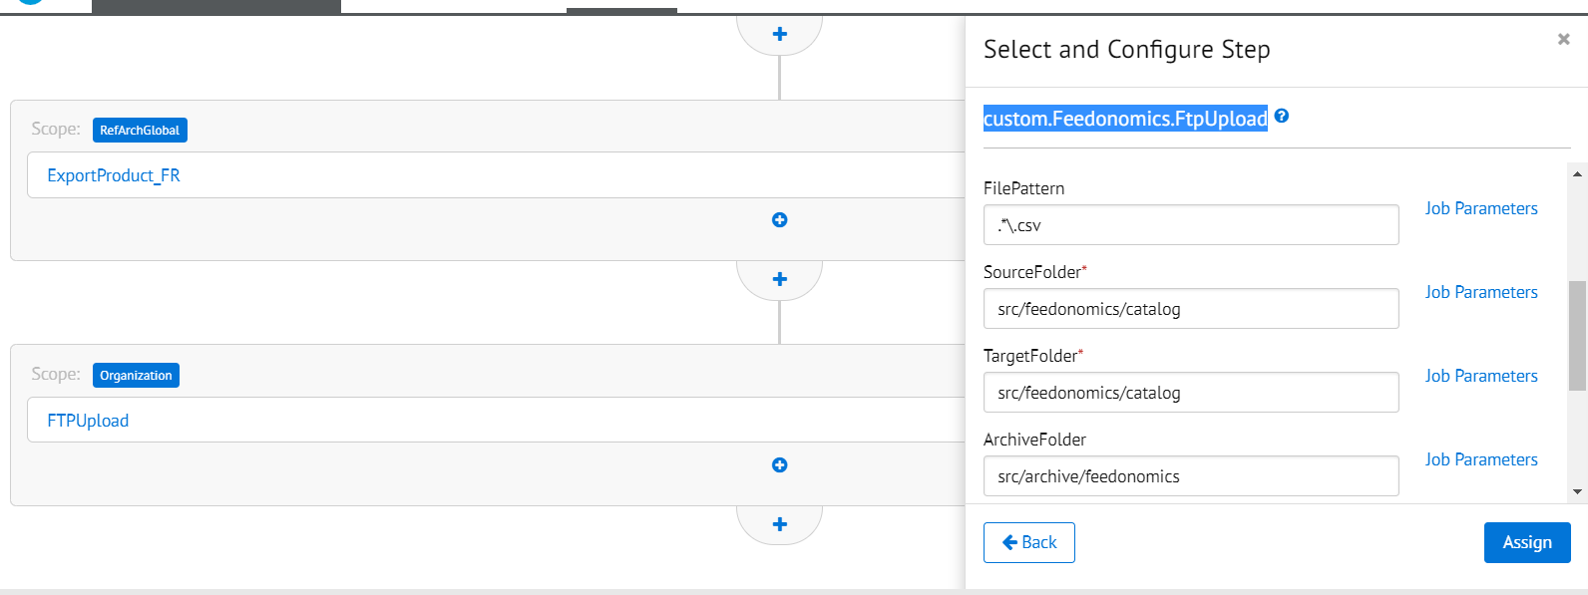
***This step run in organization context only and will copy to FTP all files created in previous job steps.

External Interfaces
FTP service credentials are required with feedonomics before the JOB run. Please contact Feedonomics Support for the same.

Availability
Feedonomics services are expected to be available at all times. Should there be a service failure, the retailer will be notified via error emails with an address sourced from a configurable site preference
Feedonomics will need to be contacted in the case of unexpected downtime of its FTP service downtime.

Support
Support is to be provided through your Feedonomics representative in the first instance. Refer to the following link.
https://app.feedonomics.support/portal/home

User Guide

Roles, Responsibilities
The error email address defined in the JOB’s Notification setting should be monitored proactively to address any issues with the jobs.

Business Manager
After importing the metadata, schedule the JOBs as per the requirement.
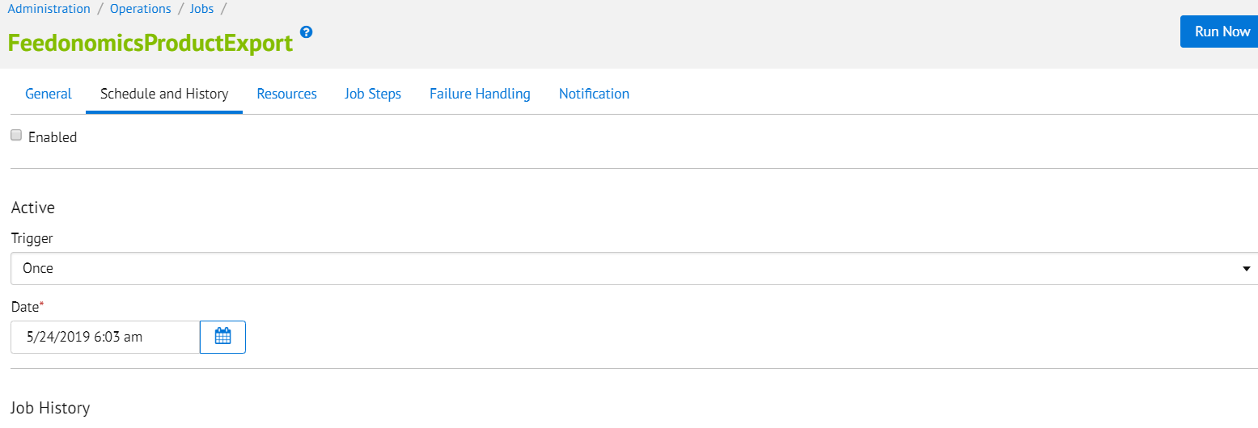
Set the email address for notification on JOB failure.
`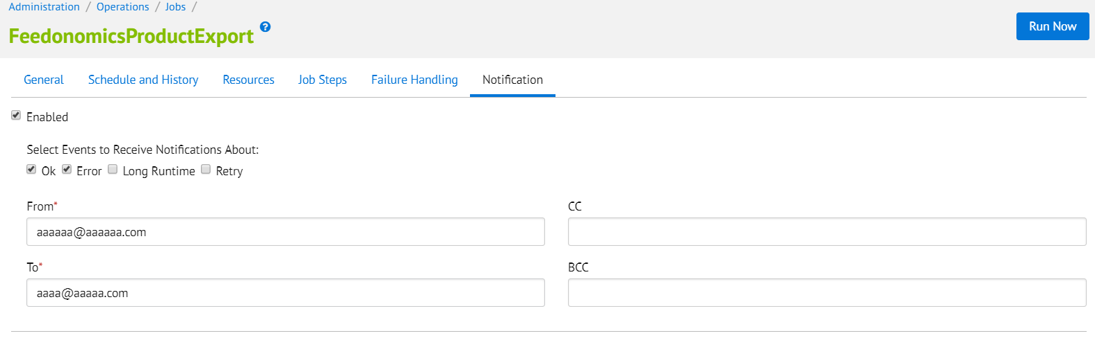

Testing
In order to test this cartridge, run FeedonomicsProductExport and FeedonomicsInventoryExport jobs after configuring them. After successful export files will be archived to the respective archive folder at IMPEX location and will be uploaded to (S)FTP location. In case of error please refer to job error logs for detailed info and contact Feedonomics.

Known Issues

If any job runs more than 60 mins and gives the script timeout error then raise a Salesforce Support Ticket they will check the required configuration on your system like elastic search and will enable the same.

Release History
Version | Date | Changes
19.6.0 | 5/30/2019 | Initial release
19.7.0 | 10/24/2019 | Updated for ImageViewType & Available only parameter
20.1.0 | 8/12/2020 | a) Updated version and included additional param Online Only.  b) Included additional fields in feed files viz. primary Category,  preorder backorder allocation, availability status message.

